

**Vicious Cycles**

Patterns don’t just come at us one by one. They are clustered in “vicious cycles,” where one pattern can lead to another and then another, forming this “familiar” sequence of feelings, thoughts, and behaviors.

The cyclical structure of the vicious cycle channels the energy of the patterns, increasing their power. The patterns tend to alternate in no particular order through feelings, thoughts, behaviors, moods, beliefs, expectations, and admonitions.

Mapping out a vicious cycle can help to gain greater awareness of the actual patterns, beliefs, and feelings that are active. It can help first to identify a major pattern or shame message. Then, ask yourself a series of questions to help identify the patterns that compose the vicious cycle:

To begin mapping a vicious cycle, start with:

* A specific situation where you get triggered
* A shame belief
* A core belief you hold about yourself

Ask yourself, “What happens next?”

* What am I feeling? What are my fears? What is my mood?
* What am I thinking or saying? What do I tell myself? What do I say to others?
* What am I doing or sensing? What is the effect on my Body?
* What do I do to avoid or compensate?
* How do I act? What is my behavior?

For example:

* When I’m in this pattern, what do I do? *Identify pattern in the response.*
* When I do that, how do I feel? *Again, identify pattern in each response.*
* When I feel that way, what do I do or what am I thinking?
* There is no “correct” order to ask these questions. Pay attention and be naturally curious about this inner dynamic.

Not all vicious cycles resolve themselves into neat, closed circles. It is more important to chart out the flow than to try too hard to close it and lose connection to the sequence of patterns.

**Vicious Cycle Example**

Situation – I feel powerless in my relationship.

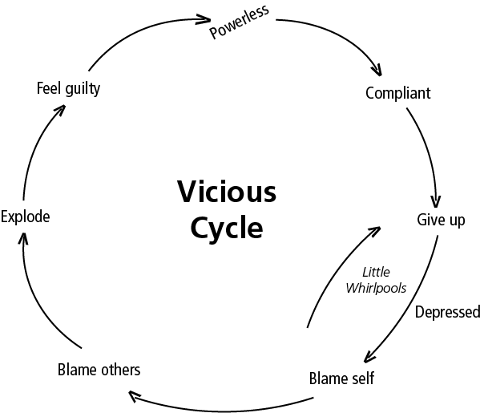

**Vicious Cycle**

Shame Belief:

**Vicious Cycle**

Situation

**Patterns Identified in Vicious Cycles**

* Adopted Directly from Parent: M/P1, F/P2, S (Surrogate)
* Learned in Reaction or Rebellion to Parent: M/P1-R, F/P2-R, S-R

|  |  |  |
| --- | --- | --- |
| **Patterns = Who I am NOT** | **Parent** | **Authentic Alternative = Who I AM** |
|  |  |  |
|  |  |  |
|  |  |  |
|  |  |  |
|  |  |  |
|  |  |  |
|  |  |  |
|  |  |  |
|  |  |  |
|  |  |  |
|  |  |  |
|  |  |  |
|  |  |  |
|  |  |  |
|  |  |  |
|  |  |  |
|  |  |  |

**Patterns Identified in Vicious Cycles**

* Adopted Directly from Parent: M/P1, F/P2, S (Surrogate)
* Learned in Reaction or Rebellion to Parent: M/P1-R, F/P2-R, S-R

|  |  |  |
| --- | --- | --- |
| **Patterns = Who I am NOT** | **Parent** | **Authentic Alternative = Who I AM** |
|  |  |  |
|  |  |  |
|  |  |  |
|  |  |  |
|  |  |  |
|  |  |  |
|  |  |  |
|  |  |  |
|  |  |  |
|  |  |  |
|  |  |  |
|  |  |  |
|  |  |  |
|  |  |  |
|  |  |  |
|  |  |  |
|  |  |  |